Robotics

**Unit 1 User’s Guide**

Introduction to Electric Circuit

horizontal line

# 

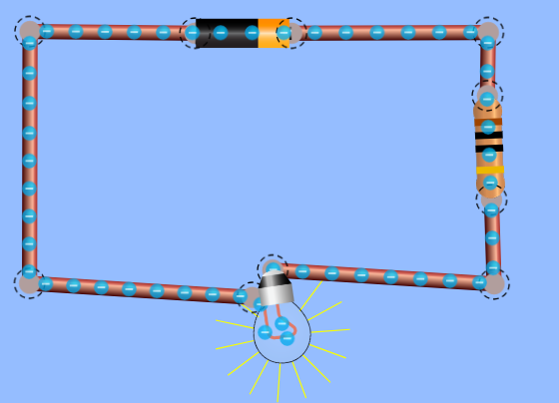

**Ctrl+Alt+Elite**

**CONTENT OF UNIT 1 SLIDES**

# Unit 1: Introduction to Electric Circuits

**Section 1: Basics Of Electric Circuits**

* Current Flow
* Electric Components
  + Resistors
  + Diodes (L.E.D)
  + Battery (Power Source)
  + Potentiometer

**Section 2: Introduction to BreadBoard**

* Soldering
* Applications
* Building the Hot Wire Game

# OVERVIEW

# Students will explore electricity through different means. This unit is an introduction to Circuits. Students will learn the basics of electric circuit. How and why we use circuit. At the end of this unit students should be able to build a simple circuit using a breadboard, a light bulb and a resistors. They should also be able to differentiate between an series connected circuit and a parallel connected circuit. This unit contain several activities that illustrated the above descriptions.

# FOCUS STANDARDS

# From our experience implementing this unit, we have selected these focus standards.

# Describe what is current and how it flows in an electric circuit.

# Describe what an electric circuit is.

# Describe why current flow from point A to point B using the waterfall and/or water tank analogy.

# Engage effectively with the student to ensure they understand how current flow in a circuit.

# Go over the observations made during the explanation of the water tank analogy.

# Describe each electrical components used in this section with them and explain why they are needed in the circuit.

# Describe how a breadboard works.

# Explain how the pins connection are connected to each other.

# OBJECTIVES

These set objectives are to be checked at the end of this unit. Students should know the minimum of the following objectives to move forward.

# Compare and contrast the water tank analogy to an actual electric circuit.

# Build a simple circuit using a battery, a resistor and a LED (light bulb).

# Student should be able to build a circuit using a breadboard.

# Students should know the differences between series and parallel circuits.

# Students should be able to solder two wires together with supervision.

# SAMPLE ACTIVITIES

The activities listed below are to completely by the end of the unit 1. All are build using a breadboard.

* Build a circuit using a 9V battery, a 1k $Ω$ resistor and a LED.
* Build a circuit using a 9V battery, a 1k $Ω$ resistor and two LEDs.
  + Connect them in series.
    - What happened if one LED is removed.
      * Deduct conclusion
  + Connect them in parallel.
    - What happened if one LED is removed.
      * Deduct conclusions
* Which connection is more effective between parallel and series circuit?
* Controlling the brightness of a LED using a potentiometer.
  + Use a 9V battery, a potentiometer and a LED to build a circuit.
    - This activity introduce the notion of variable resistance that will be advanced in future units.
      * Deduct conclusion on why the brightness of the LED change according to how much resistance you set to.

# *TERMINOLOGY*

In this section, all the complexes words used in this unit are detailed and explained below.

**Electric Potential**: The 9V battery used in this unit.

**Current:** Movement of charge in the Circuit.

**Resistor:** Electrical component that resistor the passage of current inside the circuit.

**Solder:** Solder is a metal alloy. It is usually made out of tin and copper. It is lead free solder. Solder melts between 210- 230oC.

**Bill of Materials**

List of items needed for this units are:

* **Resistors** ( Instructors is free to use resistors with different resistance value.) Do not used very high resistance because it prevent the light bulb from lighting up. The 1 kΩ resistors are good for the activities in this unit.
* **L.E.D** : These are the light bulb used in this unit.
* **Breadboard:** The support we used throughout this curriculum to connect different electrical components in the circuits we build.
* **Battery:** The 9V power source we use the power up the circuits.
* **Copper Wire:** Electrical conductor used for the hotwire game
* **Wire Stripper:** Tool used to strip wires for the soldering activity
* **Foam:** Used a the base for the hotwire game. Can be replaced by wood
* **Buzzer:** Can replace the LED in the hot wire game
* **Potentiometer:** Electrical component used in Activity #3 to control the brightness of the LED.
* **Wires:** Electrical conductor used throughout this unit to connect different components together on the breadboard.

**Timeline**

This timeline is an estimated of how long this unit should take to cover all the materials and ensure the students understand the concepts

**Unit 1**: A minimum of three one hour sessions

1. One hour to cover from beginning to activity #1..
2. One hour to get to activity #2.
3. One to soldering and build the hotwire game.